SEMESTER TWO
Papers written by
Australian Maths Software

YEAR 12

MATHEMATICS METHODS

Units 3-4

2017

Section One
(Calculator–free)

Name: _________________________________

Teacher: _______________________________

TIME ALLOWED FOR THIS SECTION

Reading time before commencing work: 5 minutes
Working time for section: 50 minutes

MATERIAL REQUIRED / RECOMMENDED FOR THIS SECTION

To be provided by the candidate
Standard items: pens, pencils, pencil sharpener, highlighter, eraser, ruler.

IMPORTANT NOTE TO CANDIDATES

No other items may be taken into the examination room. It is your responsibility to ensure that you do not have any unauthorised notes or other items of a non–personal nature in the examination room. If you have any unauthorised material with you, hand it to the supervisor before reading any further.

To be provided by the supervisor

Question/answer booklet for Section One.
A formula sheet which may also be used for Section Two.
Structure of this examination

 | Number of questions available | Number of questions to be answered | Working time (minutes) | Marks available | Percentage of exam
Section One  Calculator—free | 8 | 8 | 50 | 52 | 35
Section Two  Calculator—assumed | 12 | 12 | 100 | 98 | 65
Total marks |  |  |  | 150 | 100

Instructions to candidates

1. The rules for the conduct of this examination are detailed in the Information Handbook.
Sitting this examination implies that you agree to abide by these rules.

2. Write your answers in the Question/Answer booklet.

3. You must be careful to confine your responses to the specific questions asked and to
follow any instructions that are specific to a particular question.

4. Spare pages are provided at the end of this booklet. If you need to use them, indicate
in the original answer space where the answer is continued i.e. give the page number.

5. Show all your working clearly. Your working should be in sufficient detail to allow your
answers to be checked readily and for marks to be awarded for reasoning. Incorrect
answers given without supporting reasoning cannot be allocated any marks. For any
question or part question worth more than two marks, valid working or justification is
required to receive full marks. If you repeat an answer to any question, ensure that you
cancel the answer you do not wish to have marked.

6. It is recommended that you do not use pencil, except in diagrams.

7. The Formula Sheet is not to be handed in with your Question/Answer booklet.

1. (6 marks)
(a) The graph of 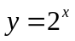 is graphed on the set of axes below.
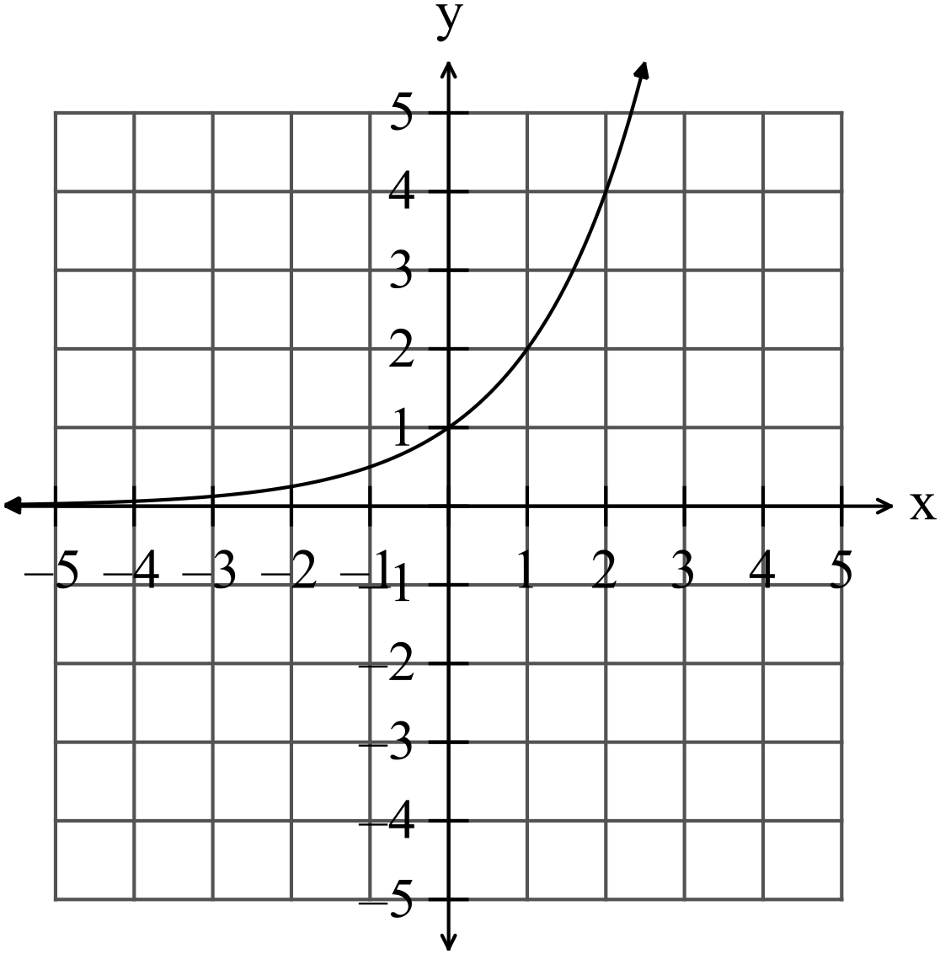
(i) Sketch 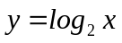 on the set of axes above. (2)
(ii) Describe the relationship between 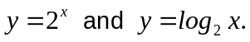 (1)

(b) Prove that 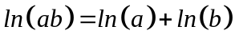. (3)

2. (9 marks)
(a) Find the derivative of
(i) 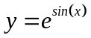 (1)

(ii) 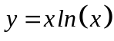 (2)

(iii) 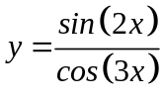 (3)

(b) Let and hence find
gradient at 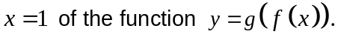 (3)

3. (5 marks)
(a) Estimate the area between the function 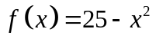 and theaxis for
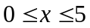 using rectangles from above. (3)
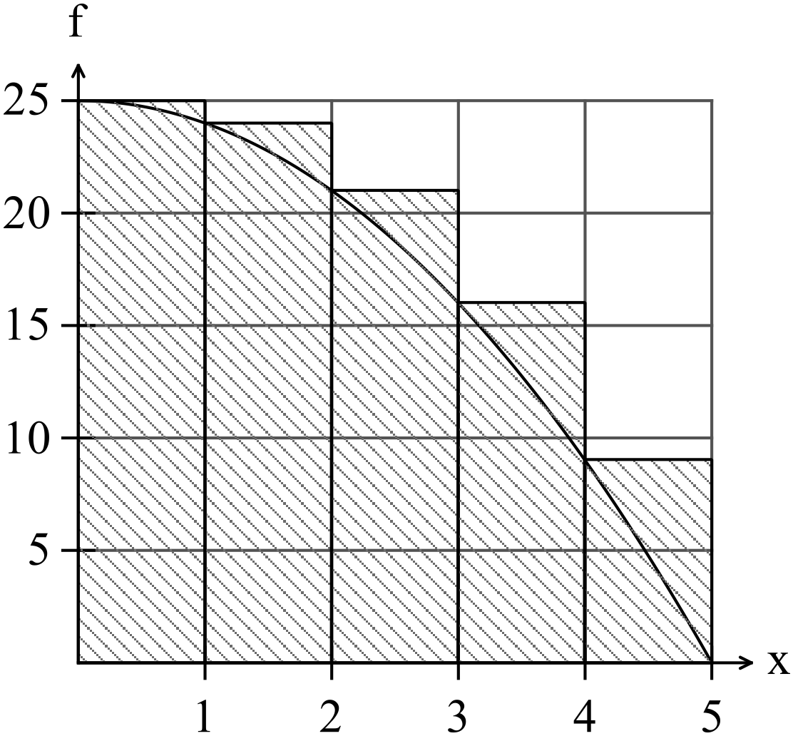

(b) Suggest whether using rectangles from above or below is the most accurate in
this case and explain why. (2)

4. (8 marks)
(a) Find
(i) 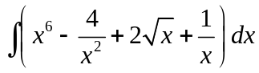 (3)

(ii) 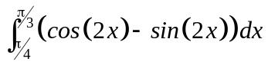 (3)

(iii) 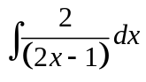 (1)

(b) Simplify the expression 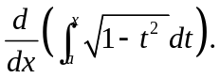 (1)

5. (3 marks)
Sketch the function on the set of axes below that has the following features. (3)

x | -5 | -4 | -3 | -2 | -1 | 0
f | - | 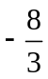 | - | -4 | - | +
f’ | + | 0 | - | 0 | + | +
f” | - | - | 0 | + | + | +

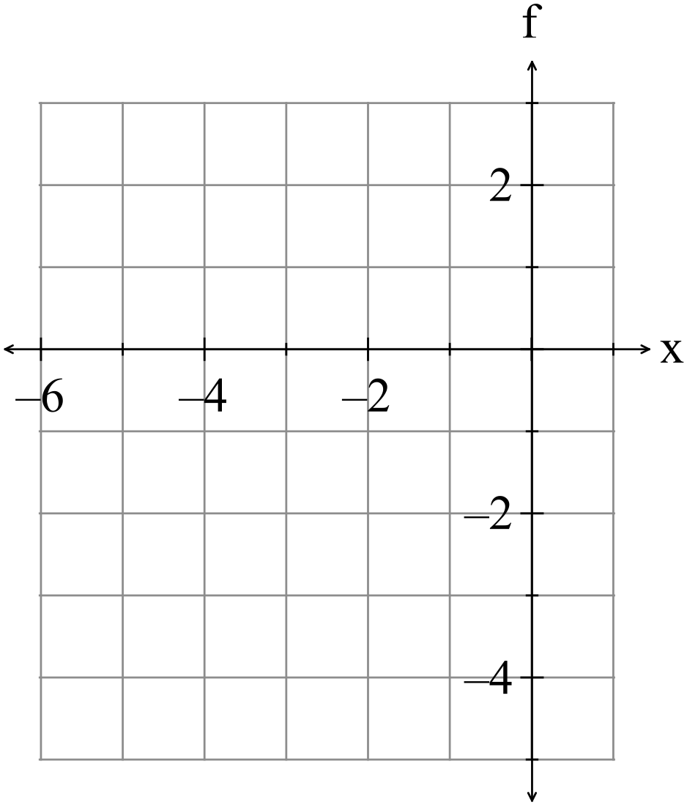
6. (2 marks)

Given the function 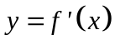 sketch the function 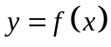
on the set of axes below. (2)
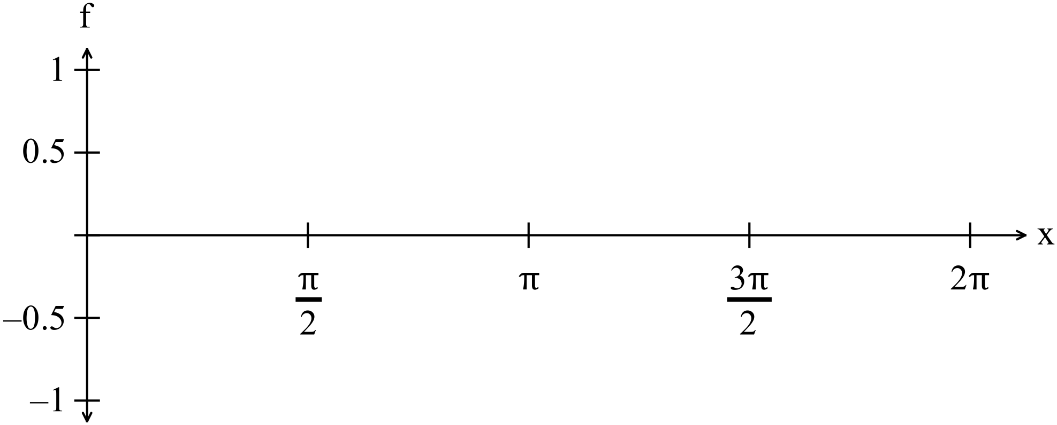

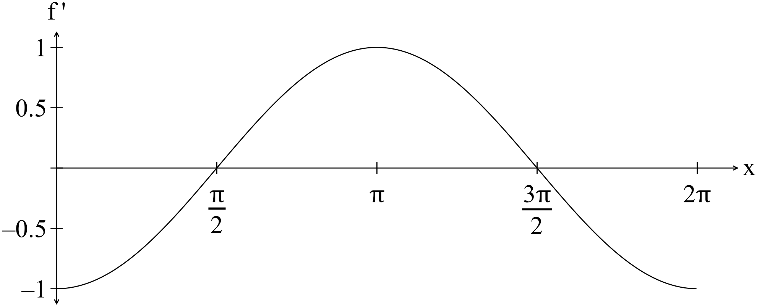

7. (9 marks)
(a) The probability density function for the discrete random variable  is
shown on the chart below.

x | 0 | 1 | 2 | 3
P(X = x) | 0.2 | 0.4 | 0.3 | 0.1

(i) Find the expected value nce of the distribution. (2)

(ii) Write down the expression that if evaluated gives the variance of the
distribution. (2)

The variable in (i) is transformed by the equation 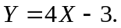
(iii) Determine the expected value of . (1)

(iv) What number would you have to multiply the variance in (ii) by to obtain the
variance of ? (1)

(b) The continuous random variable has the probability density function graphed
below.
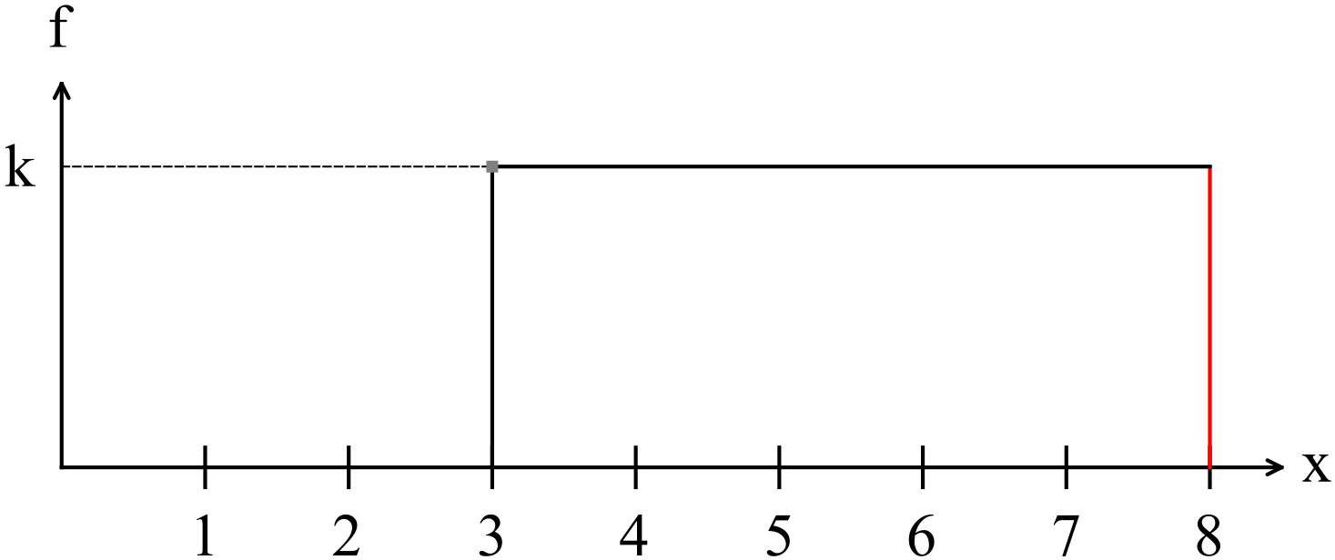

Determine

(i) the value of k. (1)

(ii) 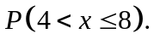 (2)

8. (10 marks)
(a) Explain exactly how to obtain a random sample of 10 integers between 1 and 20
using your calculator. (3)

(b) A set of football attendees were asked their opinion on the increase in parking
fees in the CBD.
Comment on any possible bias that may affect their response. (2)

(c) Explain why two random samples of the same size from the same distribution
may have different means and standard deviations. (2)

(d) The sample proportion of university students who have taken a part time job in
the past year is 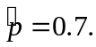
Ten random samples of students are selected and the students in each sample
are asked if they have taken a part time job in the past year.
The proportion means of each sample is recorded.

(i) Explain why the distribution of sample means form a normal distribution. (2)

(ii) Write down the expression that if evaluated gives the standard deviation of
the distribution. (1)

END OF SECTION ONE
Extra page for working if necessary

